Bug list of the websites
- Veloxn.com
- The LinkedIn link is not working properly.
Link to Site - https://veloxn.com





- Sanjaysoftware.in
- Everything is working perfectly fine.
Link to site - https://sanjaysoftware.in/
- Koshainventory.com
- There is scroller at the footer
Link to site - https://koshainventory.com

- Footer logo is not visible

- The sign in is not working even for admin
Link to site - https://koshainventory.com/app/login

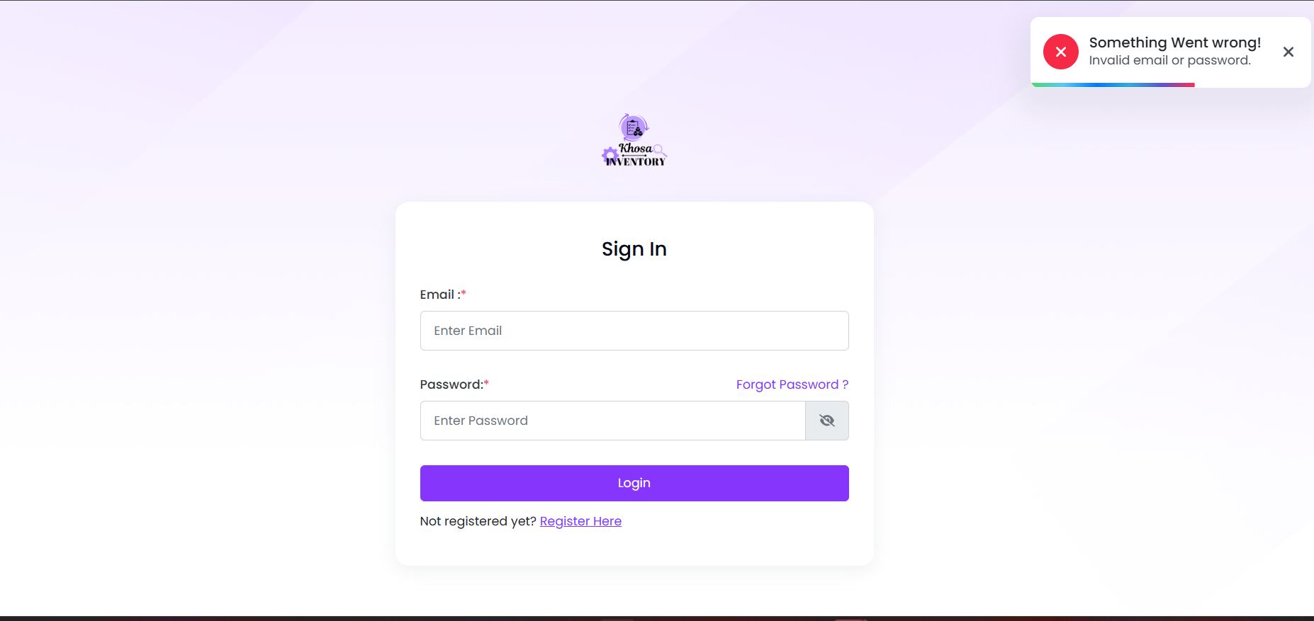

- KoshaOrganic.com
- Checkout page is not working properly
Link to site - https://koshaorganic.com



- Osre.in
- Working fine but not fully built.
Link to site - https://osre.in

- Maxgrowangel.com
- Working fine but not fully built
Link to site - https://maxgrowangel.com

- Naukripath.com
- Logo is too small.
Link to site - https://naukripath.com



- Working fine but still building
- Healen.com
- Some of the social media links are not working.
Link to site - https://healens.com/



- Everything else is working fine.
- Peoplecamp.in
- Page is not found.
Link to site - https://peoplecamp.in/

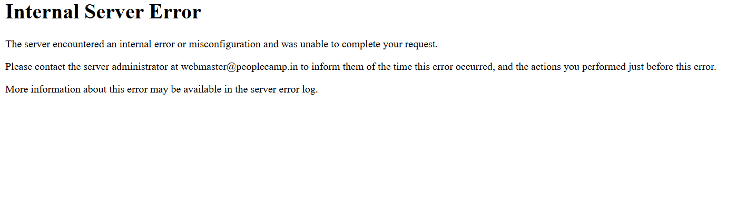

10. PublicPrimeNew.com
- The news detail page is not working.
Link to site - https://publicprimenews.com



- Everything else working fine.

11. Doctorfinder.co.in
- No Registration form.
Link to site - https://doctorfinder.co.in


- Don’t know how to enter in this site.
12. FreshEggs.co.in
- This site is not found.
Link to page - https://fresheggs.co.in


13. Reviewstyle.in
- Working fine but not fully built.
14. Optschool.com
- The form is not working properly.
Link to site - https://optimstudy.com/admissions

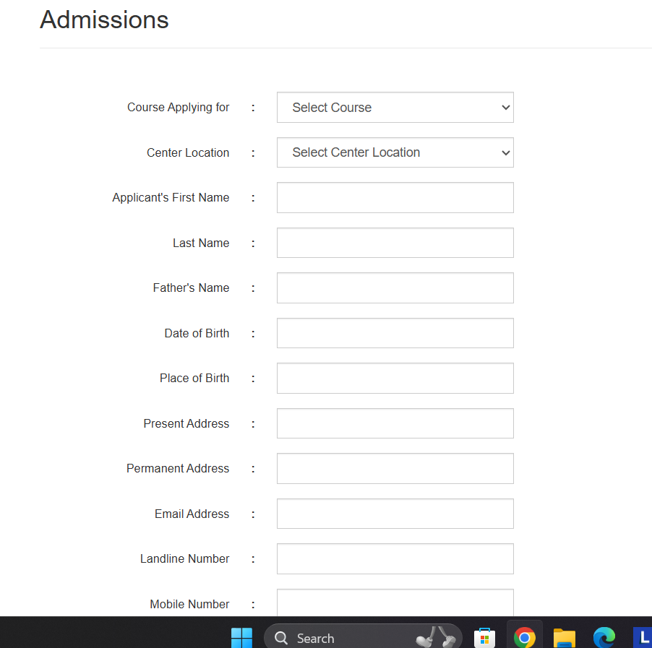
- This form is sending any mail to user.
Link to site - https://optimstudy.com/enquiry

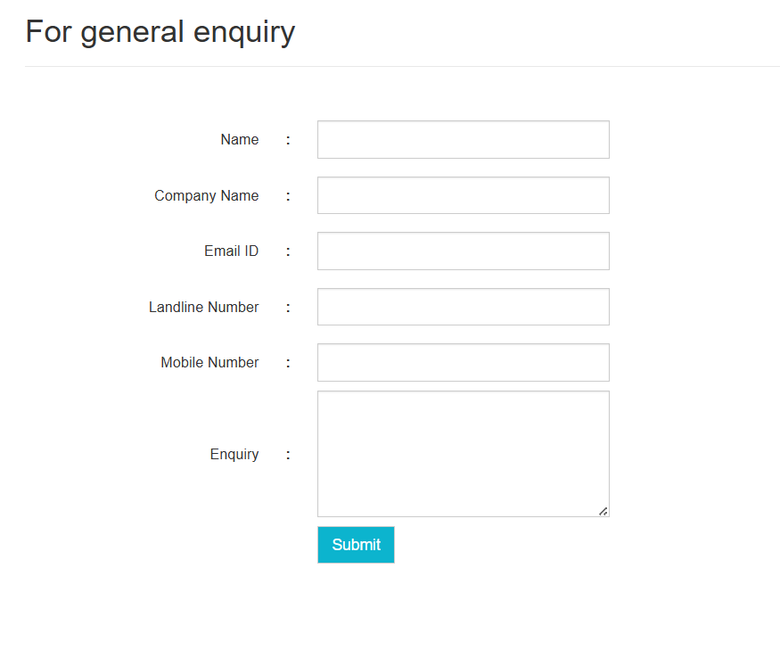
- Few of the links here are not working.


15. Perfectseeds.in
- Search is not working.
Link to site - https://perfectseeds.in/
- Contact form is not working.
Link to site - https://www.perfectseeds.in/home/contact-us

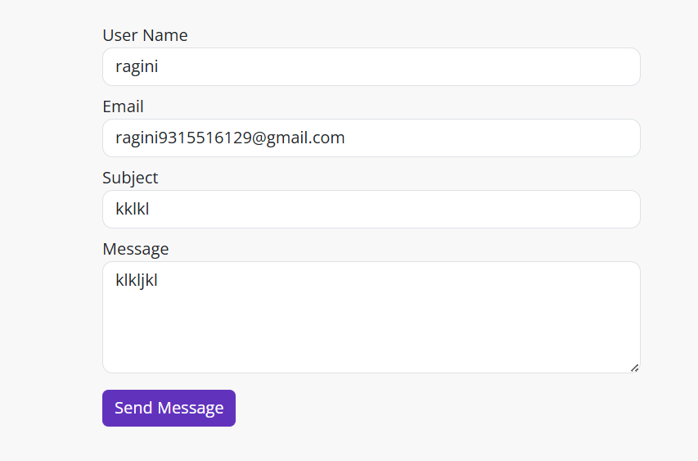
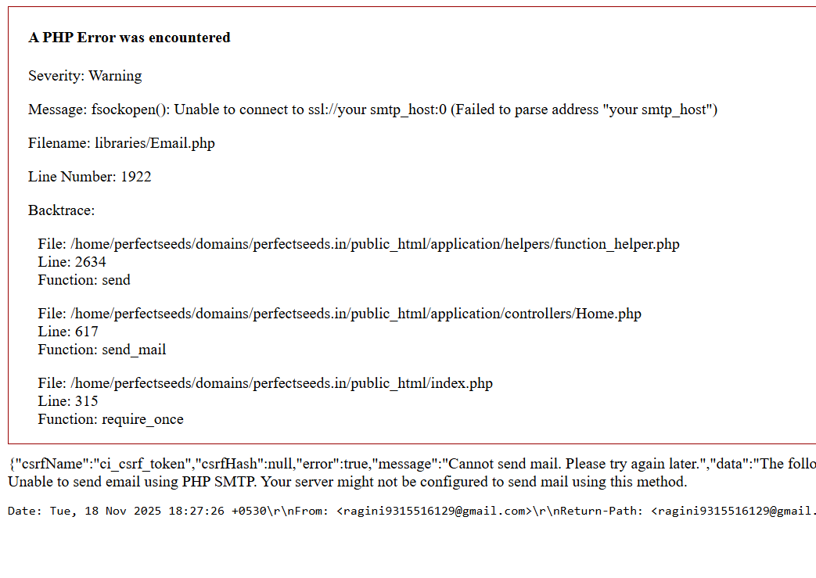
- Add to cart is not working. The internal services are not working like buying or add to cart
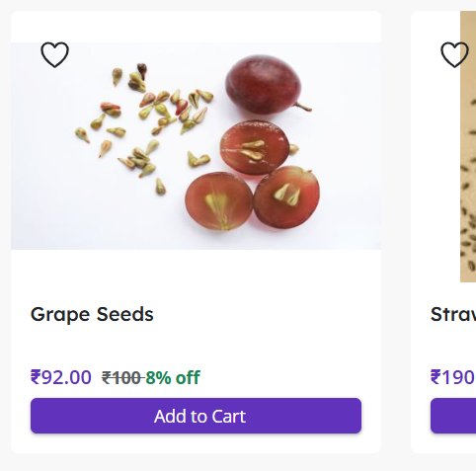

16. Optimstudy.com
- The site is just same as https://optschool.com
Link to site - https://optimstudy.com
17. Traderabbits.com
- Working fine but not fully built.
Link to site - https://traderabbits.com
18. Trueqrcaller.com
- Working fine but not fully built.
Link to site - https://trueqrcaller.com
19. Ozopg.com
- Working fine but not fully built.
Link to site - https://ozopg.com
20. Devpooja.com
- Working fine but not fully built.
Link to site - https://devpooja.com
21. Yatrawatra.com
- Working fine but not fully built.
Link to site - https://yatrawatra.com

